HOME ABOUT US ENGINEERING SERVICES SKILL DEVELOPMENT TRAINING CENTER EVENT GALLERY CONTACT US
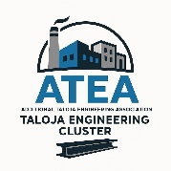

WHO WE ARE
Engineering Cluster Pune : Common Facility Center
Established in 2025, going to provide high-tech services and material testing to MSMEs in Taloja. It supports the automobile, Infrastructure and real estate sector with advanced machinery services and includes a training center for industrial skills, supplying skilled manpower to the industry. Located in the significant industrial hub of Taloja Midc, the cluster is dedicated to enhancing MSME productivity, competitiveness, and capacity building. Managed by Taloja Engineering Cluster

It aims to improve performance of small scale industries in the Engineering , Auto, Infrastructure and real estate sectors through service support of high-end machining and skill development initiatives. It helps in high tech fabrication and metal protective services.

Vision & Mission
To deliver 24/7 high-end machinery and NABL-accredited metal testing services using advanced technology and skilled experts, while offering industry-ready training for the automotive and engineering sectors.

We are dedicated to providing fast, efficient, and high-quality services to ensure complete customer satisfaction. We strive for continuous improvement and aim to be a trusted partner in our industry.

IMPROVE INNOVATE HIGH QUALITY STANDARDS

ENGINEERING SERVICES

5 AXIS Vertical Machining Center - MakinoDA300

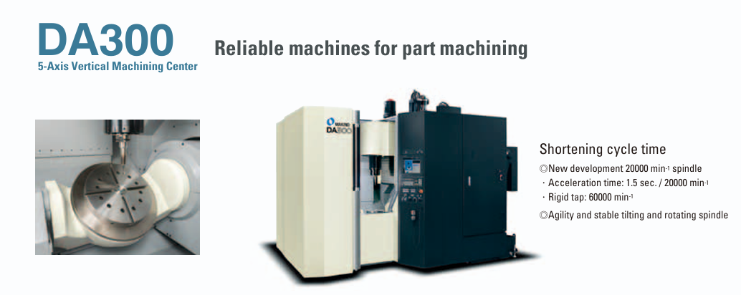
 | 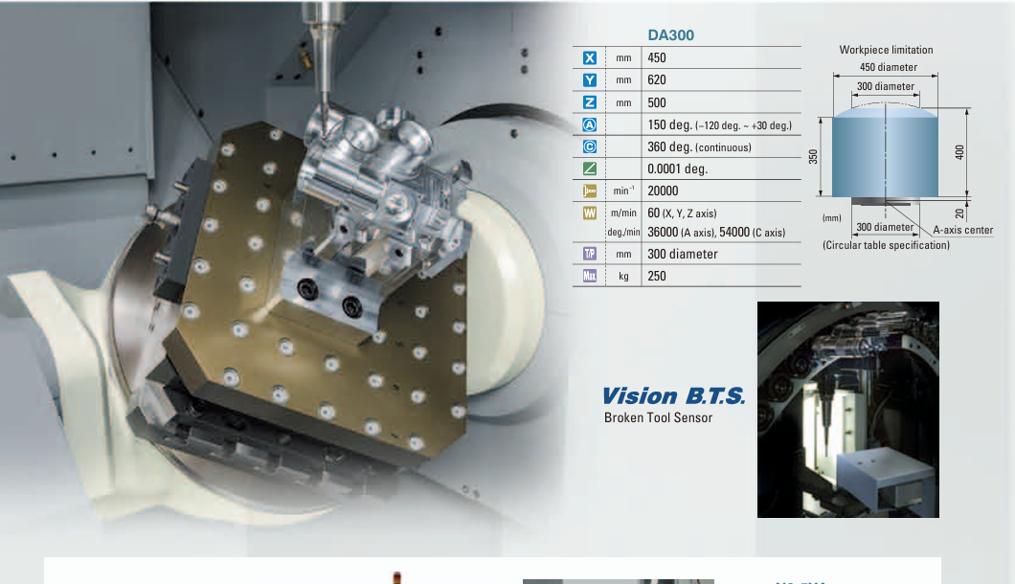
 | 5 AXIS Horizontal Machining Center – Makino a500Z
 | 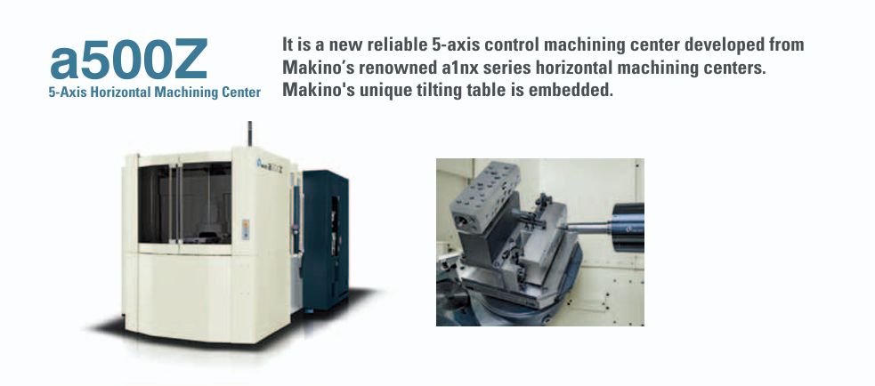
 | 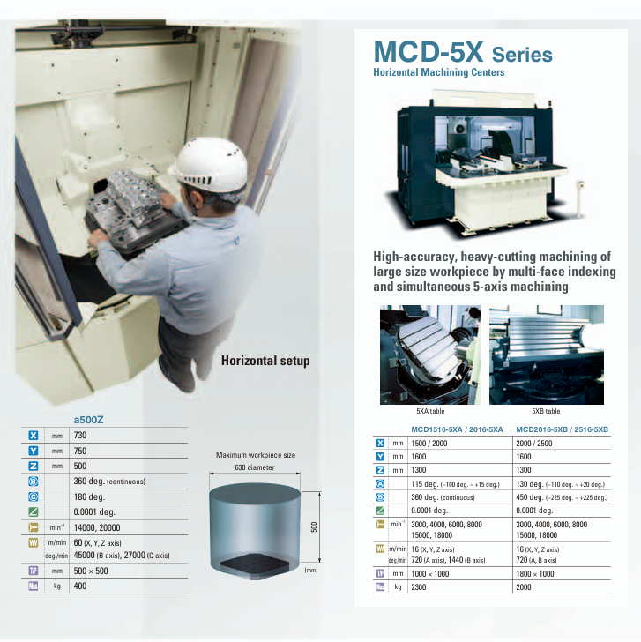
Taloja Engineering Cluster

HOT DIP GALVANISING PLANT

Description
1 |  | size of plant | 5.5m Long x 1.2m Wide x 1.5m Deep (with provision for 6.5m long kettle for expansion)
2 |  | type of product | Sundry
3 |  | size of product
4 |  | capacity of plant ( tons /hour) | 1.5 ton /hour or say 1000 MT /month
5 |  | Fuel to be used. | LPG /CNG
6 |  | contact person names | Satish Shetty, Harish shetty, Ashok Jain
7 |  | mobile number | 8080006900 , 9820639026, 9820292729
8 |  | Company Name | Jayashree Galva P Ltd
9 |  | address | Plot no A 62 ,midc Taloja ,District Raigad,Taluka Panvel. 410208
10 |  | Email ID | talojaengineeringcluster@gmail.c
11 |  | Land size | 5576 sq mts
12 |  | Process tanks size | 7.5mx 1.2 m
13 |  | Hot air dryer | 7.5Mx1.2m
 |  | HOT DIP GALVANISING PLANT
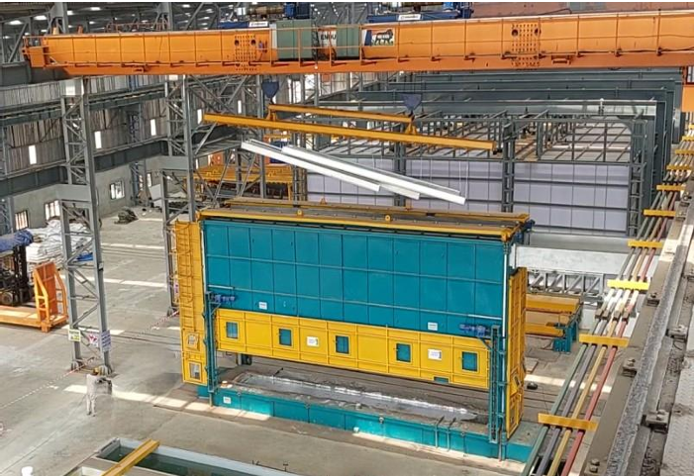

Fully Automatic CED Phosphating line with powder coating batch type Plant
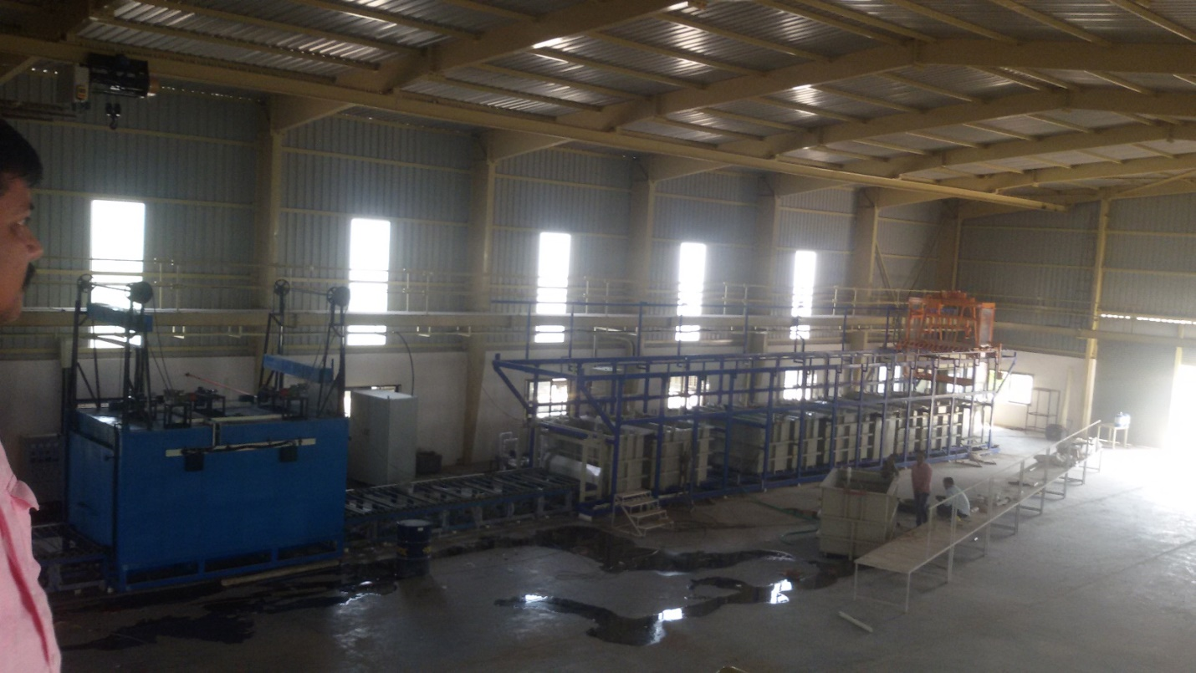

ZINC FLAKE COATING PLANT
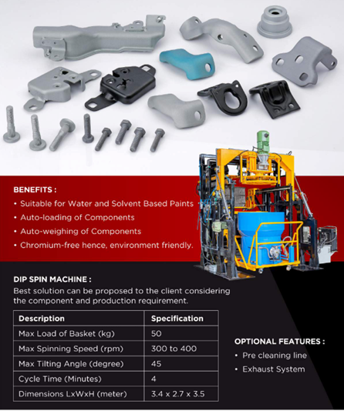

POWDER COATING
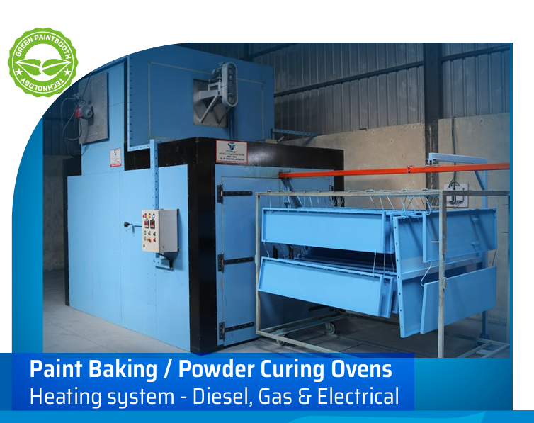

EPOXY PAINT SPRAY BOOTH
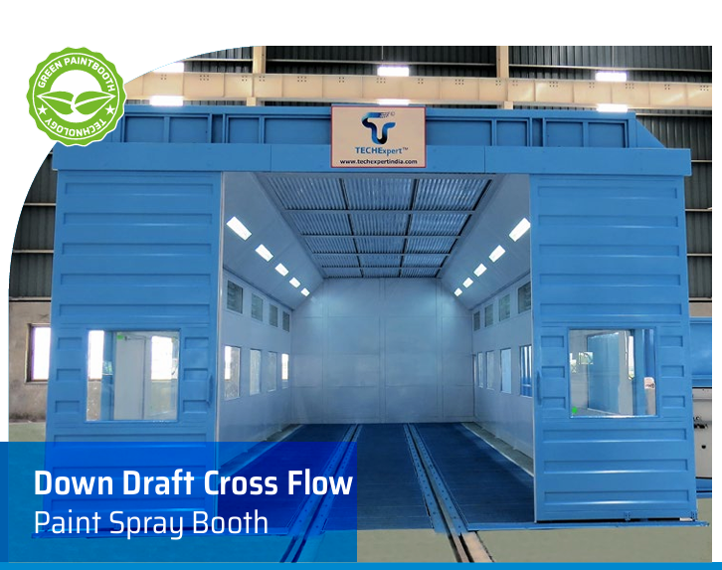

SHOT BLAASTING MACHINE
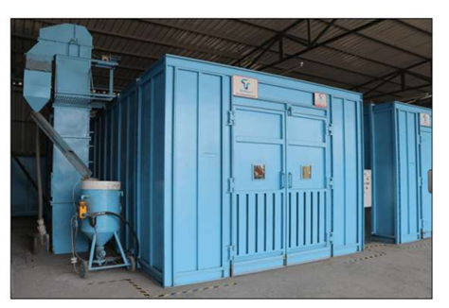

Taloja Engineering Cluster
Engineering Services Contact Us
5 axis Horiizontal Machining Center Address: Taloja Engineering Cluster
Machine shop OS 9, MIDC, Taloja Industrial Area,
NABL Approved Metal Testing Lab Taluka Panvel 410208.
Skill development Training Center Phone: +91 8080006900
Hot Dip Galvanising Process
Copyright © 2025 Taloja_ Engg_Cluster

